PCB504 Instrumentation

Lab 3 Let’s build an ECG amplifier

The overall aim, of this lab program is to build and test an ECG amplifier and interface it to an IBM computer so that signals can be displayed, stored and processed. The first part of the exercise will be to build, test and understand the ECG amplifier. (N.B. The power supply is not shown in the diagrams in this lab, however you still have to connect the op-amp chips to the power supply!). In this section of the lab it is very important to do a neat job, otherwise you will end up with a circuit that is very difficult to diagnose when there's a fault.

Preliminary observations
Turn on the CRO, set the time base to 5ms per division and, using channel 1, touch the probe to your skin somewhere - like the inside of your wrist. You should observe a large 50Hz signal, anything up to 20V_{pp}. While observing the signal, move towards and away from one of the power cables feeding the lab benches. For reference, make a note of the approximate amplitude of the 50Hz signal you observe and effect of proximity to the power cable.
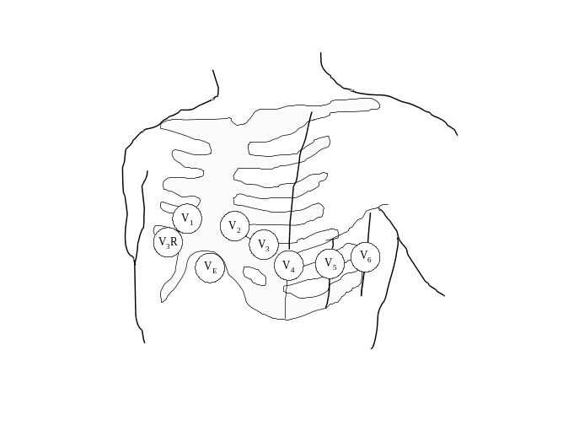

Chest showing ECG lead positions.

Now use both channels (on the same sensitivity setting) and touch one probe to the inside of your left wrist and the other to your chest near V4 or V6 ECG electrode position - see diagram - positioning is not critical and you might need your partners help to hold the probes. If your clothing gets in the way then use your other wrist. Observe both signals on the CRO. You should notice that they appear similar if not identical.

The ECG signal that you are going to try and amplify is the difference between these two traces - it is of the order of 1mV in amplitude and impossible to observe at this stage. You are going to need a very good differential amplifier to remove the 50Hz common mode signal! If, as suggested above, you observe a common mode signal of nearly 20V_{pp}, then your amplifier is going to need a CMRR of about 90dB just to reduce the effect of the 50Hz signal to the same magnitude as the ECG signal; to get a decent signal to noise ratio (SNR) a CMRR of near 120dB would be necessary! This is way too high for us to even think about building.

You need to look at what causes this 50Hz signal and attempt to reduce it as much as possible before going after the tiny ECG signal. A good first rule of thumb in instrumentation is to reduce the noise sources as far as possible before attempting to amplify the signals.

As your tests should indicate, the signal is caused by proximity to the power cables I the building. Essentially we are all “connected” to the 240VAC mains by virtue of the small capacitance formed between the power cables and our bodies. An equivalent circuit might look like the one below.

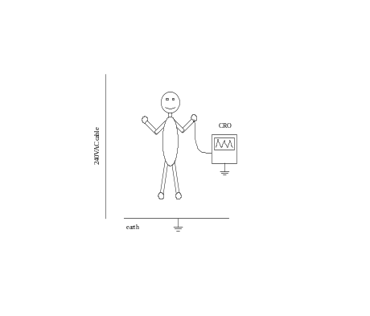
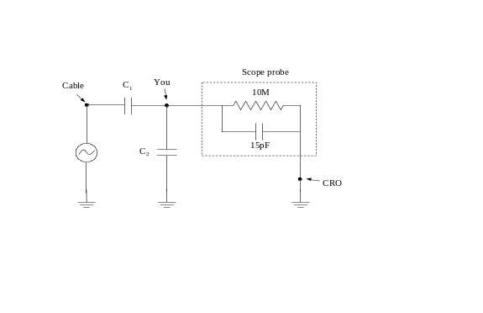

Physical arrangement. Equivalent circuit.

C₁ and C₂ are the “stray” capacitances between you and the power cable and you and ground respectively. Unless you get very close to a power cable then C₁ and C₂ will be of similar magnitude.

If you ignore the CRO probe in the equivalent circuit then you are essentially standing at the middle of a voltage divider formed by C₁ and C_{2.} If you assume C₁ ₌ C₂ then what voltage are you at with respect to ground? Why don’t you feel and electric shock?

What is the impedance of the CRO probe at 50Hz?

(Hint: 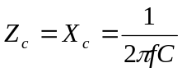 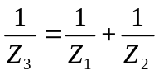)

240VAC is nearly 680V_{pp}. Based on the measurements you made above and the impedance of the CRO probe, calculate an order of magnitude for the C₁.

Remember that your first task is to reduce the size of the 50Hz signal to your body. The easiest way to do this is to “earth” your body with a cable. This is normally done using an electrode attached to the right ankle. Get one of the ECG skin electrodes and stick it to the inside of your right ankle - just behind the bone is a good place, connect it to ground (the clip on the CRO lead) and repeat the tests as you did before.

Why does earthing your body reduce the 50Hz signal?
Why does earthing your body not reduce the 50Hz signal to zero?
Hint: Think carefully about an equivalent circuit.

Power supply
Since you are going to connect the ECG circuit to your body, use the 9V batteries provided to power the circuit. While there is very little chance of a shock from a circuit powered from the minilab ±15V supply, that doesn’t rule out the potential for you to plug the circuit into the wrong socket. So to eliminate any chance of an accident (which is what you are going to have to do in a real design) use battery power - this is the simplest method of isolation. However, DO NOT use batteries until you are actually going to connect yourself to the circuit. The reason for this is to conserve batteries! Use the Minilab power supply as in the previous lab sessions, however set it to ± 9V.

Connect the batteries to your prototype board as shown below so that you have ±9V and 0V running the length of the board. This gives you easy access to the power supply for a number of circuit elements.

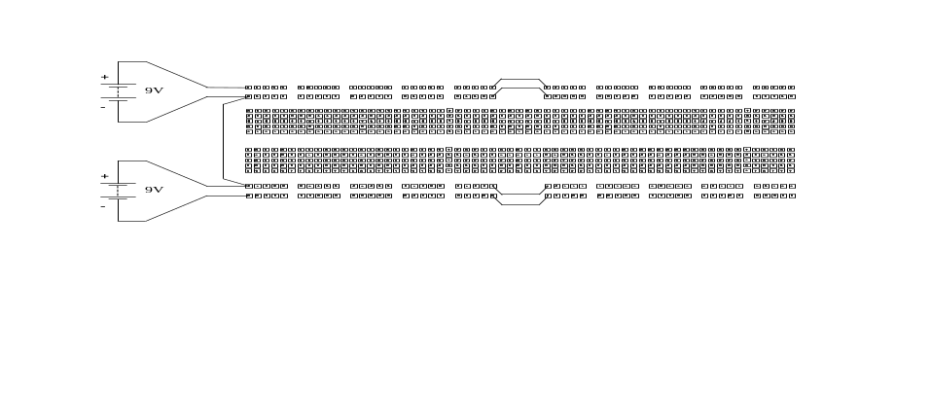

Connecting batteries to a prototype board.

Because your circuit is powered by batteries, the 0V is not automatically connected to ground as it would be if you used the mini-lab power supply. You will therefore need to add a connection from 0V to GND using another cable.

When building the circuitry for this part use the left-hand end of the board - you will keep this circuit and add bits to it later on.

Instrumentation Amplifier
There are basically two reasons why you can’t use the differential amplifier that you used with the strain gauge in a previous lab. The first is that the CMRR isn’t high enough. The second is that the input impedance is too low.

The defining characteristics of an instrumentation amplifier are (among other things) high gain, differential inputs and high CMRR - just what you need to amplify the ECG signal. These characteristics sound like those of an ideal op-amp and they are - the problem is that op-amps cannot be made “ideal enough” and too many non-ideal properties. The circuit for a standard instrumentation amplifier uses three op-amps as shown in the diagram.
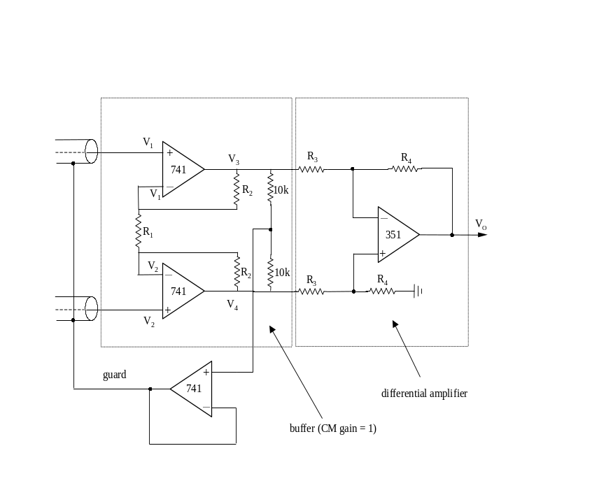

Instrumentation amplifier.

Note that the power supply connections to the op-amps have been left out for clarity.

The circuit to the right of the dashed line is the same differential amplifier that you used with the strain gauge bridge. It has a differential gain of R₄/R₃ and a CMRR which is basically limited to about 60dB even with careful matching of the resistor values.

The circuit to the left of the dashed line has a common mode gain of 1 and a differential gain of 1+2(R₂/R₁) and huge input impedance. Work out these results for yourself using the golden rules.

You can buy precision made instrumentation amplifiers like the circuit shown above, in a single integrated circuit. Usually all the resistors are pre-packaged along with the amplifier except for R₁ which is usually left for you to supply to set the gain. Better instrumentation amps will have a selection of values for R₁ built in and you select from one of these. Instrumentation amps are somewhat expensive so you are going to build one from cheaper op-amps. The result will not be as good, so always buy a pre-made instrumentation amp for a real application.

Start by building up the part of the amplifier to the left of the dashed line using R₂ = 100k and R₁ = 4k7 and LF351 op-amps for U1 and U2.

Test this part of the circuit before proceeding with the rest of the circuit: Connect both the inputs, V_{A} and V_{B} to the minilab signal generator and drive the inputs with 2V_{pp} at 100Hz. Check the signals at the output of the op-amps U1 and U2. Are they what you expect?

Ground the V_{A} input and apply a small signal to the V_{B} input and check the differential gain; careful, this part of the circuit has two outputs, one from each op-amp and the overall output is the difference between these two signals. Repeat for V_{B} grounded.

Now build the final differential amplifier. It is a good idea to check that it works before connecting it to the first part of the circuit. Use R₄ = 47k and R₃ = 10k. Measure the resistors and try to get them all the same value, or at least R₃, R₄ pairs in the same ratio, so that you get good CMRR in this part of the amplifier.

Once you are sure that both sections of the circuit work, connect them together and do a general check of the operation of the whole circuit, ie. that it amplifies differential signals and not common mode signals.

Connect both inputs to ground and measure the output voltage with a multimeter. You will probably notice that the output has a DC offset, ie. the output is non-zero with both inputs grounded. You need to get rid of this to achieve the best results from the circuit and to make use of the maximum possible output range. To do this add a 10k or 20k trim potto either of the input op-amps as shown here.
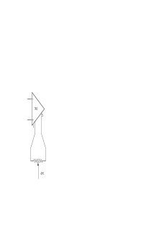

Adjust this until you get zero volts on the output with both inputs grounded. (A trim pot is a small potentiometer that you find in the draws below the fixed resistors - the long rectangular ones are best since they have a “10 turn” range and allow finer adjustment. Trim pots are meant to be used where you must make an adjustment like this only once and leave the value fixed until the equipment is serviced again.)

Now do a careful check of the expected differential gain and measure the CMRR for the whole circuit.

Observing an ECG signal
Get two more skin electrodes and attach one to the inside of your left wrist and the other to either V4 or V6 electrode positions on your chest - these positions give the best signals. Connect these to the input of your amplifier circuit using the leads provided. Note that these leads are shielding - leave the shields disconnected for the moment. Make sure your right ankle is still earthed and that the 0V of your circuit is connected to the same earth.

Look at the output of the amplifier with the CRO. Can you see any signal or variation which coincides with your heartbeat? Sit still and relax while you are doing this. If your amplifier saturates then measure the voltage between the two electrodes on your body with a voltmeter - it should be less than about 20mV. If it is larger than this then try removing the electrodes and swabbing the skin with metho before applying new electrodes.

You probably still have significant amounts of 50Hz interference on the amplifier output, making the ECG signal difficult to see. Recall the level of 50Hz signal that you observed after earthing your right ankle and the CMRR that you calculated for your amplifier. Is the amount of 50Hz signal on the output accounted for in terms of these numbers?

Try connecting the shields of the connecting cables to ground on your circuit (again, make sure that 0V on your circuit is the same as the ground on your ankle). Why does this reduce the 50Hz interference so dramatically? Explain what is happening in terms of an equivalent circuit.

Can you account for the level of 50Hz signal on the output now the shields are grounded? If you can’t see and 50Hz signal then try putting your hand near one of the power cables to boost the signal on your body.

You will probably notice that the output has a large DC value. This is due to the electro-chemical effects at the skin electrodes - see “half cell potential” in the Biomedical Equipment Technology text. This DC offset is a problem both because it changes with time and because it uses up some of the available output. There are tow approaches to getting rid of this. One is to “AC couple” the amplifier by placing capacitors in series with the inputs as shown on the right - don’t do this, just look at the circuit and read on.

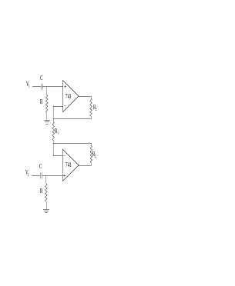

Why does this eliminate the DC component from the input signal? (Think about the relative impedances of C and R as a function of frequency and use the “good old voltage divider” concept).

The extra resistors, R, have to be added. Otherwise the input bias currents of the op-amps will be forced to flow through the capacitors causing the output to drift and saturate. (The same problem occurs in your existing circuit if the earth electrode on your ankle falls off).

The problem with this approach is that you need to use very large values of R in order not to compromise the input impedance, which was a major reason for choosing this circuit. You also need to choose values so that 1/(2πRC) is small compared to the lowest frequency signals you expect in the ECG, about 0.05Hz. Explain why! This can lead to the problem that the circuit may take an inconvenient amount of time to stabilise after connecting it to a patient or changing the electrode lead connections.

Another way of coping with the DC offset due to small differences in half-cell potentials is to cancel it out manually. This is viable since it changes slowly. Do not be tempted to try removing the DC offset by adjusting the trim pot that you added to the circuit previously. Major adjustments to this will cause problems with the CMRR of the op-amp being trimmed.

Another problem is that you could probably do with some more gain. Our goal is to amplify the ECG signal into the range 0V to 5V because this is the range required by the interface cards in the computers that we have. Both problems can be addressed by adding another stage of amplification with a DC offset adjustment. Add another simple inverting amplifier to your circuit:
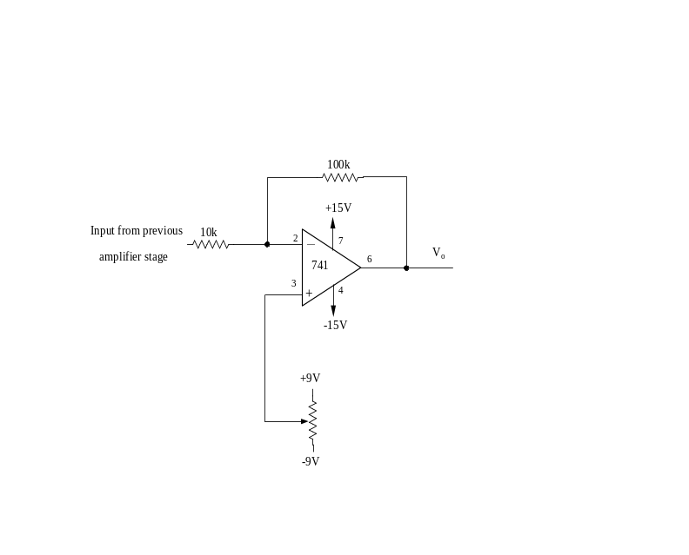
Adjust the potentiometer to get your ECG output in the range 0V to 5V. It will probably drift out of this range in a relatively short time and you will have to re-adjust the potentiometer - this is because the half-cell potential drifts. If this becomes a serious problem then reduce the gain of the final stage amplifier.

In a practical ECG circuit the voltage on pin 3 of the final stage amplifier would be adjusted automatically to maintain the DC component at the desired value - ie. 2.5V for a signal varying between )v and 5V. Can you think of a way to do this? Hint: An integrating circuit may be of use. Don’t bother attempting to do this as there is not enough time.

Now you should have a reasonable ECG signal. You might try different electrode positions and compare the signals with what some of the textbooks say you should see. Do not be alarmed if you see strange signals - this is not a certified piece of medical equipment!

While observing the ECG, try clenching the muscles in the arm with the electrode attached and see the somatic artefact.

Filtering
There are tow things you might consider doing with filters in your circuit. The first would be to try and remove any remaining 50Hz interference with a notch filter. Notch filter design is not trivial - you need to be very careful with resistor and capacitor values otherwise the notch ends up in the wrong place or is too broad or too narrow.

You could try a simple “twin T” filter as shown here if you think you have enough time.

To centre the notch on frequency f_{c} you need to select values for R and C so that:

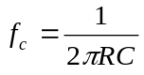

To get 2C, put two C’s in parallel and 2R can be made with two R’s in series. You will probably find the performance of this filter disappointing. If you build it, test it using the minilab signal generator as an input. The poor performance is due to imperfect matching of the resistor and capacitor values.
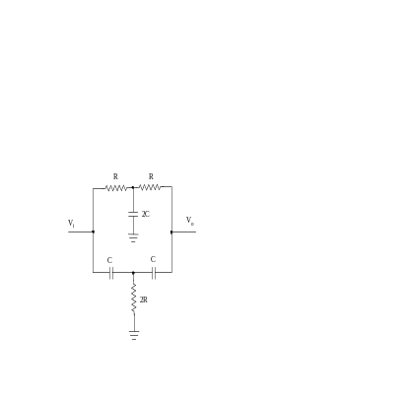

The second thing, which you should try, is to add a low pass filter which will remove most of the somatic artefact (and some of the 50Hz at the same time). Use the active filter circuit shown below.
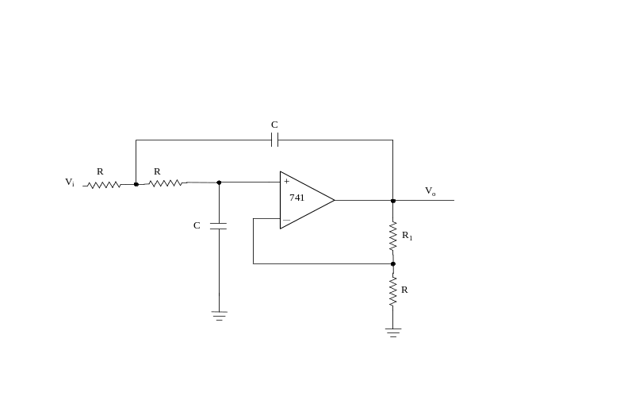
Chebyshev filter.

Use a 741 op-amp and values of R = 120k, R₁ = 100k and C = 0.047μF. This is a Chebyshev filter with a nominal “corner” frequency of about 20Hz.

Check its frequency response and plot the response as a Bode plot (ie. dB versus log(f)). Check the phase response too.

Feed your ECG signal through it and see if it removes the somatic artefact and note its effect on any 50Hz noise. Is the low frequency shape of the output waveform noticeably different to that of the input? In other words is the phase response of the filter distorting the important features of the ECG?

